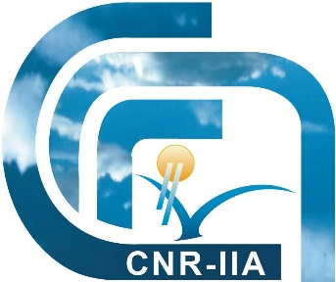

Practical arrangements for

Workshop

“Elements to consider when designing a Global Monitoring Plan for Mercury”

GEF - Funded Project

Project ID: 5409

Venue:

National Research Council of Italy - Research Area Rome 1 Montelibretti (CNR - AdR RM1)

The Final Workshop of UNEP-GEF Project “Development of a Plan for Global Monitoring of Human Exposure to and Environmental Concentrations of Mercury” will be held at the Conference meeting Room of CNR Montelibretti Research Area (CNR - AdR RM1) the oldest and largest research area of the Italian National Research Council (Consiglio Nazionale delle Ricerche – CNR), located at approximately 30 km outside Rome, in the North-Est region.
The CNR - AdR RM1 currently hosts 17 research Institutes with multidisciplinary activities on a total of almost 30000 square metres providing technical infrastructures and services related to administrative, technical, logistic, ICT and health security issues.

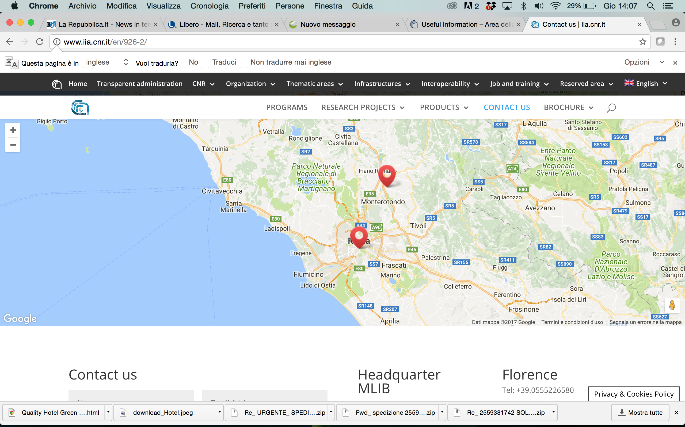

CNR - AdR RM1
CNR - Headquarters
Map of exact position of CNR - AdR RM1 Montelibretti.

Visitor Information
The CNR - Institute of Atmospheric Pollution Research (CNR-IIA), belonging to the CNR - AdR RM1 Montelibretti, is located nearby Monterotondo Scalo with convenient access to a major highway (Roma-Firenze) and a very convenient train connection with Fiumicino Leonardo da Vinci Airport and Roma city area.
The nearest train station is “PIANABELLA DI MONTELIBRETTI”, at a walking distance from the main entrance and security check point.

How to get to CNR - AdR RM1 Montelibretti (or to CNR-IIA)
By car – Taking the highway (A1 Roma-Firenze) and leaving this main way at Castelnuovo di Porto (Rome) and then following the map until Area della Ricerca Roma-1, via Salaria km. 29,300.

By train and metro - The Tiburtina Station is well connected with our institute (you have to step out of the train at the station “Pianabella di Montelibretti” 6 stops from Tiburtina Station) since it provides a train connection in both directions every 15 minutes –
from there you may go directly to Fiumicino Airport (about 1 hr and 15 min).

From Leonardo Da Vinci (Fiumicino) Airport - from the airport take the train service FR1 towards Fara Sabina-Orte to the Pianabella di Montelibretti stop station, then walk for 300 m towards the CNR AdR RM1 Montelibretti entrance. Then take your personal pass at this main entrance.

Entry/ID Requirements
Visitors must present and leave their identification information to the receptionists, who would have the participant list registered to the workshop. Visitors will receive an appropriate badge by the local CNR staff.

CONFERENCE HALL
The Conference Hall of CNR - AdR RM1 can host up to 120 attendees.
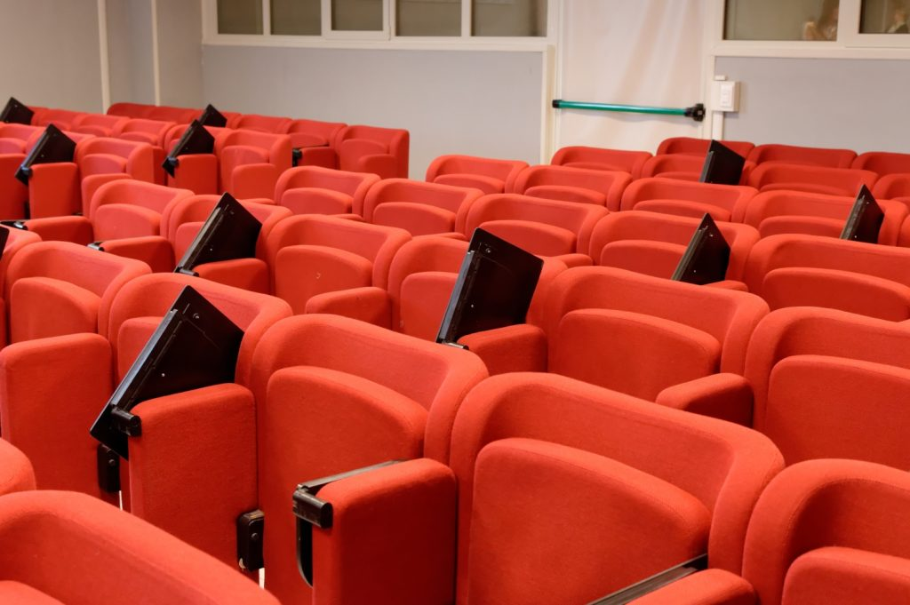
The infrastructure can host lectures and small-medium size workshops, and includes:
– Secretary reception desk and internet point;
– Space for poster sessions, breakfasts and coffee breaks (standing);
– Wood panels for Poster sessions
– Free internet connection (wi-fi for guests)
– Technical support for audiovisual media and equipment control and management;
– Large free parking space;
- Personal computer with Windows
– Videoprojection tools.

Hotel Accommodation in Monterotondo Scalo:

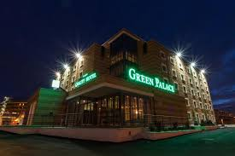

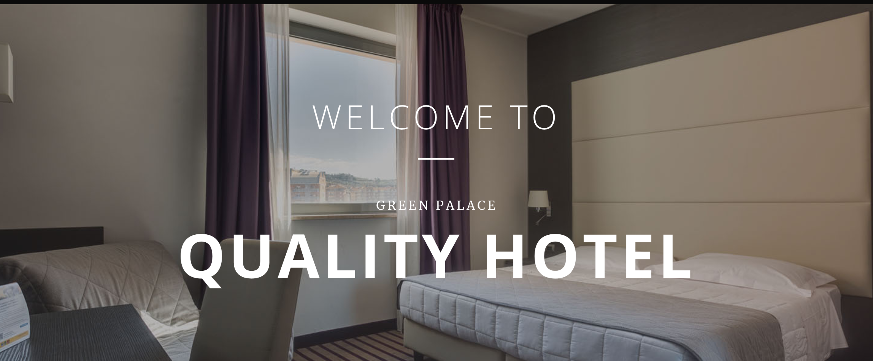

Quality Hotel Green Palace
The recommended hotel for the Final Workshop is the Quality Hotel Green Palace in Monterotondo Scalo.
The new Quality Hotel Green Palace in Monterotondo, inaugurated in March 2013 is offering his guests 100 spacious, elegant and modern rooms, 4 meeting rooms, a hotel restaurant and a lounge bar. Our hotel is ideally situated for travelers looking for convenient accommodation near Rome with a fast connection to the international airport Rome Fiumicino.
Learn more about the hotel: http://www.qualitygreenpalace.it/
Reservations for funded participants (belonging to developing countries or being partners of the project) can be made by CNR-IIA at Quality Hotel Green Palace in Monterotondo if you provide your info by sending your registration form (see Annex 1) no later than 20 December 2017 to Victor Hugo Estellano Schulze <victor.estellano@un.org>.

Hotel Accommodation in Rome:

List of Suggested Hotels close to the centre of Rome (to be booked by yourself):

1) Best Western Globus Hotel Roma – 3 star hotel
http://www.globushotel.com/

2) Ateneo Garden Palace Hotel (San Lorenzo, Roma)
(http://www.ateneorome.com/)

3) Best Western Premier Hotel ROYAL Santina (http://www.hotelroyalsantina.com/en/home-page.aspx) 4 star hotel

